**IFT 533: Project-Phase-3 Dashboard Implementation**

Aravindh Easwaran,

Sridhar Renangi,

Yogananda Reddy Murikinati,

Siva Ramakrishna Durga Sompalli

**Course:** Data Visualization & Reporting for IT

**Instructor name**: Dr Asmaa Elbadrawy

**Due date:** 11/26/2023

**Section 1: The Dashboard**

**Dashboard image:**

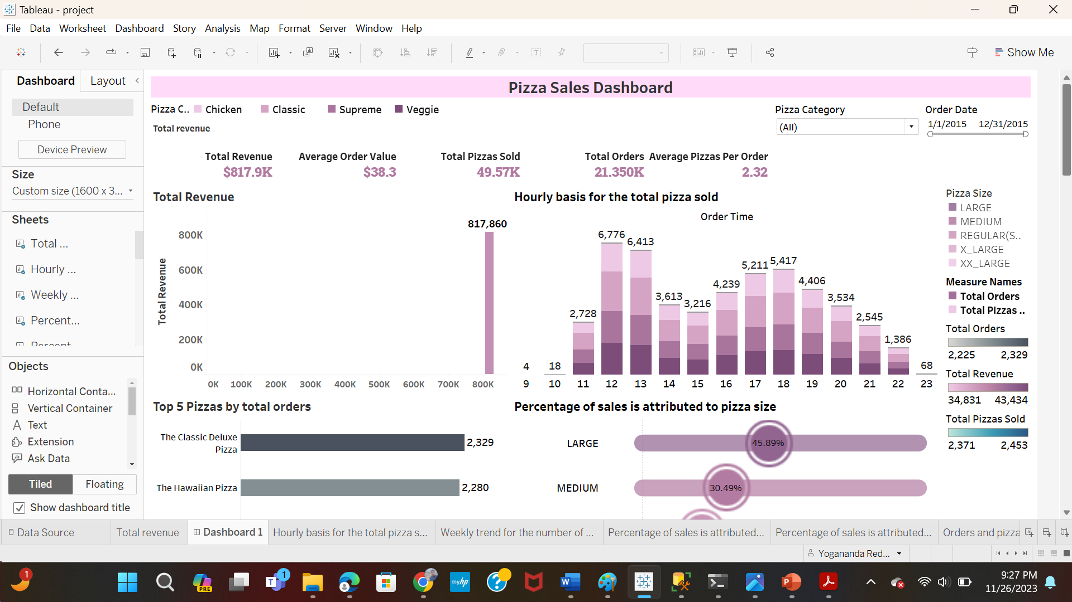

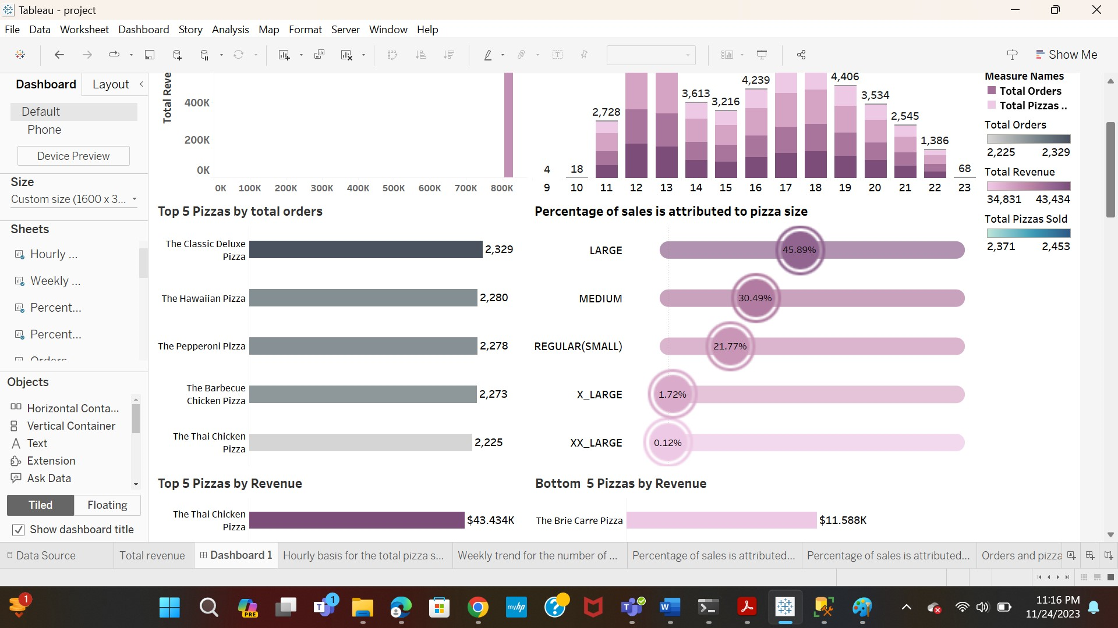

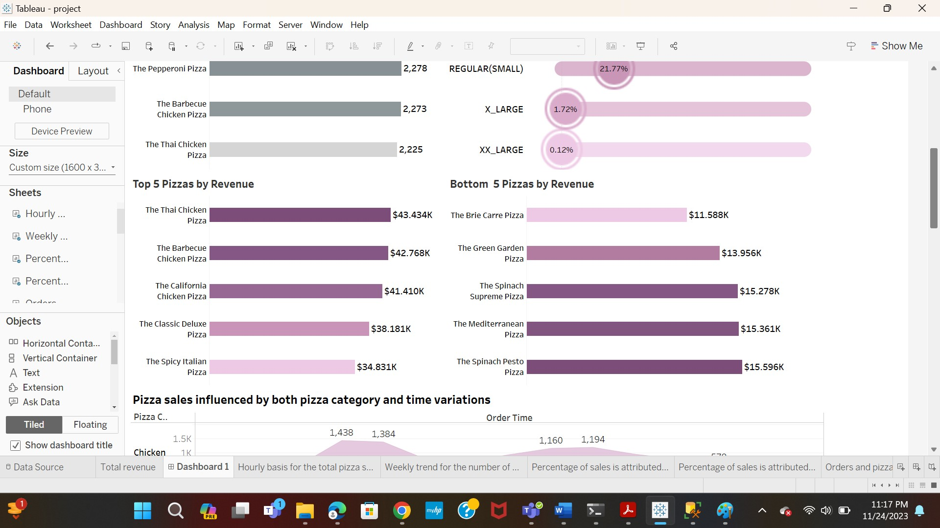

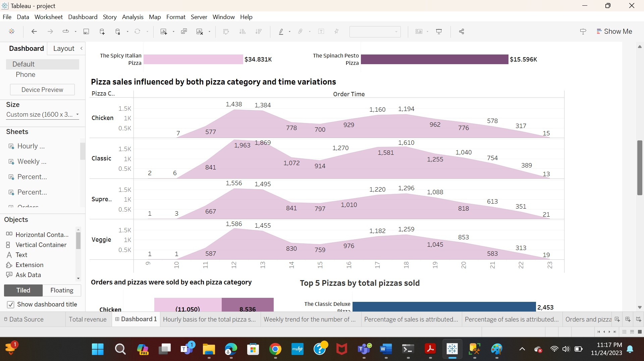

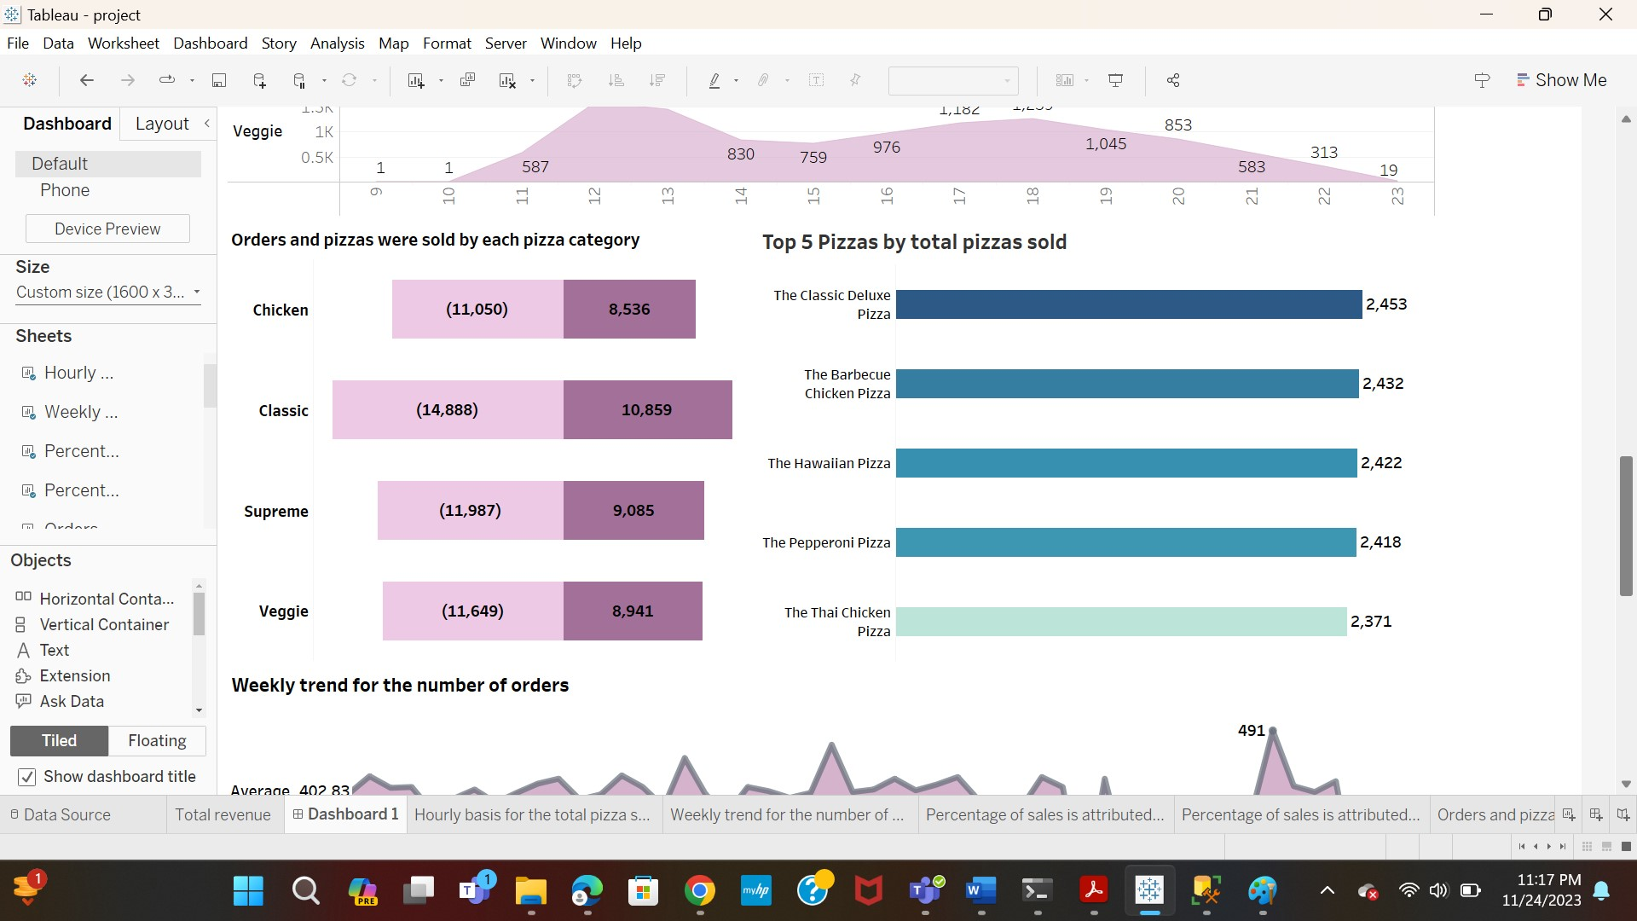





**A brief explanation of what the dashboard is used for:**

The pizza sales dashboard is a tool designed for analyzing and visualizing pizza sales data. It utilizes CSV and SQL Server to conduct a comprehensive analysis of sales trends. Calculation fields are employed to derive key metrics such as total revenue, average order value, total pizzas sold, total orders, and average pizzas per order. The dashboard incorporates 12 visualizations, including stacked bar charts for hourly trends, line charts for weekly trends, and pie charts depicting the distribution of sales across pizza categories and sizes. Through this dashboard, users can gain insights into sales patterns on a daily and weekly basis, helping to inform business decisions and strategies.

A dashboard is a useful tool that helps consumers analyze patterns by presenting and displaying data in an understandable fashion. A complete data visualization solution that offers a consolidated view of key performance indicators (KPIs) across many business operations is called a whole dashboard. It serves as a focal point for tracking and evaluating crucial indicators, empowering stakeholders to decide wisely and streamline processes. Users may choose from a variety of parameters, such as pizza category, size, and time, to customize this sales dashboard for pizza. They may now analyze sales data and trends according to the parameters they have selected.

For an understanding of the performance of a firm, key metrics are essential. Total Order Value (derived by dividing total revenue by the number of orders), Total Pizzas Sold (the total of all pizza quantities), Total Orders (the total number of placed orders), and Average Pizzas Per Order (derived by dividing the total number of pizzas sold by the total number of orders) are among the calculations.

It takes a variety of charts to graphically examine pizza sales data and identify trends. Size and sales of pizzas may be correlated, indicating that larger pizzas sell for more money. But other elements, including toppings and pricing, can also affect sales. Pizza category association is contingent upon consumer demand and preferences; larger sales may result from certain categories' greater popularity than others. Sales of pizzas can differ according to their size and category; bigger pizzas and specific pizza categories may be more popular and result in higher sales.

Season, day of the week, and time of day all affect pizza sales. Sales are often greater on weekends, and particular pizza categories have seasonal trends. Size and category-specific sales volume reveal customer preferences for changes to businesses.

Sales are influenced by size and category; for example, a large pepperoni may sell more than a tiny margarita. Businesses can refine their pricing for profitability by examining the association between total price and unit price. Businesses may improve inventory and logistics efficiency by modifying their products based on insights from the top 5 best-sellers by quantity. The total income for each category shows where offering changes can be lucrative. Optimizing pricing techniques to maximize profits can be facilitated by analyzing the total price by size and unit.

**Section 2: The Dataset**

**An explanation of the dataset:**

The pizza sales dataset is a valuable resource providing detailed information on orders processed at a pizza restaurant. With 12 columns and 48,621 rows, each row represents a different order, providing a detailed perspective of several business aspects. This dataset functions as an all-inclusive archive, gathering information that delves into the nuances of transactional details, order details, and client preferences. This extensive dataset may be used by analysts to glean insights, identify trends, and make data-driven choices that can improve overall business strategy and operational effectiveness.

**An explanation of the dataset attributes:**

* pizza_id: This column holds a distinctive identifier for each pizza type, aiding in tracking and categorizing different pizzas on the menu.
* order_id: Serving as a unique identifier for each order, this column allows for the organization and analysis of customer transactions.
* pizza_name_id: A specific identifier assigned to each pizza name, facilitating the association of pizzas with their respective names.
* quantity: This column indicates the number of pizzas ordered within each transaction, providing insights into customer preferences and order sizes.
* order_date: These columns provide a timestamp for each order, enabling temporal analysis and identifying patterns related to the time of day or specific dates.
* order_time: The time of the order.
* unit_price: Denoting the price of an individual pizza, this column is crucial for calculating total revenue and average order value.
* total_price: Reflecting the overall cost of an order, this column contributes to the assessment of total revenue and provides a comprehensive financial overview.
* pizza_size: Indicating the size of each pizza (e.g., Small, Medium, Large), this column categorizes orders based on their dimensions.
* pizza_category: This column specifies the type of pizza ordered (e.g., Classic, Veggie, Chicken, Supreme), aiding in categorizing pizzas for analytical purposes.
* pizza_ingredients: Providing a detailed list of ingredients for each pizza, this column allows for a granular analysis of the components that contribute to the variety of pizzas offered.
* pizza_name: This column contains the name assigned to each pizza, providing a user-friendly reference to distinguish between different pizza offerings.

**Pre-processing done on the data:**

We are using a CSV file, so there is no need to preprocess the data because it is simple to import into Kaggle and use for visualization. Thankfully, the dataset is tidy and free of null values, and each table has a unique header. A smooth transition into the visualization stage is guaranteed by the observable numerical values in the dataset.

Conversely, we want to enhance the analysis and visualization in this project by utilizing Tableau for a range of computed field activities. By utilizing values directly from the CSV file, computed fields and parameters are created. With the help of these computed fields, we will be able to extract additional information and insights that are crucial for the specific goals of our visualization.

**Section 3: Dashboard Users**

* **Marketing Teams:** A focused marketing campaign may be created by marketing teams by using the pizza sales dashboard to gain insight into consumer preferences and behavior. Marketing managers can modify promotions based on seasonal patterns, launch region-specific promotions to capitalize on local tastes, and tailor campaigns to specific demographics by identifying popular pizzas among various customer segments, identifying seasonal trends in sales, and analyzing regional preferences for toppings. Through resonance with consumers and maximum promotional impact, this data-driven strategy improves the efficacy of marketing efforts.
* **Product Development Teams:** The sales dashboard is used by product development teams to improve current products and make informed decisions about their workflows. Product designers may remain ahead of consumer preferences by spotting new trends in pizza varieties, gauging the desire for novel toppings, and assessing the sales of newly released pizzas. With the use of this data-driven strategy, new pizzas may be made using popular toppings or varieties, current goods can be changed to suit shifting consumer tastes, and pizzas that aren't doing well in the marketplace can be eliminated or adjusted. The dashboard is a useful tool for portfolio optimization and for making sure that product lines reflect changing customer preferences.
* **Customer Service Teams:** Customer care teams use the dashboard to solve problems found in sales data, improving the overall customer experience. They may decrease typical customer complaints by optimizing delivery routes, allocating more resources, and implementing changes when they identify regions with high wait times or regular delivery delays. Customer service managers may more effectively handle customer complaints and increase customer happiness and loyalty by using data-driven insights. A more effective and customer-focused service model benefits from real-time modifications made in response to dashboard data.
* **Stakeholders:** The dashboard offers valuable data to a range of players in the pizza sector, such as individual pizzerias, pizza chains, and pizza delivery services. Pizza restaurants may standardize or diversity their menu offers based on national trends by using the data as a useful tool to optimize menu offerings across various locations. Independent pizzerias use the dashboard to customize their menus to suit regional tastes and set themselves apart from the competition by producing specialty or unusual pizzas that appeal to certain clientele. Conversely, pizza delivery services utilize the dashboard to improve delivery efficiency and logistics. These businesses may enhance customer happiness metrics, delivery times, order volume, and customer satisfaction metrics to optimize operations and provide better overall service. For stakeholders, the dashboard becomes a key resource. differentiates their offerings, and enhances operational efficiency in a dynamic and competitive pizza industry.
* **Pizza Restaurant Owners and Managers:** The dashboard is utilized by managers and owners of pizza restaurants to maximize sales, pinpoint their most popular menu items, and improve their overall operational effectiveness. This entails analysing data to identify the pizzas that sell the best and the worst, modifying the menu in response to sales patterns, and streamlining inventory control to cut down on waste. Using this information, the menu may be streamlined by eliminating or redesigning unpopular products, adding specials for popular pizzas to increase sales, and modifying personnel numbers in accordance with peak sales periods. Owners and managers are empowered to make strategic decisions that enhance the operation of the restaurant and enhance customer happiness thanks to this data-driven approach.
* **Pizza Franchisees:** The dashboard helps pizza franchisees compare performance, pinpoint areas for development, and make sure everything is in line with the broader franchise structure. As an illustration, consider contrasting sales results with those of other franchisees in the area, figuring out where to improve based on local preferences, and making sure that standards throughout the whole franchise are followed. Using these insights entails putting high-performing franchisees' best practices into effect, customizing offers to suit local tastes while staying within the franchise's parameters, and optimizing operations using data from top-performing sites. Franchisees find that the dashboard is a crucial tool for streamlining their own operations and enhancing the overall performance of the franchise business.
* **Pizza Delivery Companies:** Pizza delivery services use the dashboard to improve customer happiness, streamline delivery processes, and efficiently handle large order volumes. This include keeping tabs on customer satisfaction indicators, streamlining delivery routes to cut down on delivery times, and tracking order volume by neighborhood and time of day. Applying these insights entails determining and resolving delivery time-related concerns, introducing promotions or incentives to increase customer happiness, and modifying workforce numbers and routes based on demand. Delivery organizations may increase productivity, optimize processes, and provide clients a better overall service experience by utilizing the dashboard.
* **Pizza Ingredient Suppliers:** The dashboard's goals for providers of pizza ingredients are to monitor demand for ingredients, spot industry trends, and maximize output and stock levels. In order to satisfy demand, examples include determining which cheeses and toppings are most popular, modifying production levels based on component popularity, and effectively managing inventories. The use of these insights include supply chain management optimization based on sales data, predicting and adapting to shifts in ingredient demand, and working with pizza restaurants to produce new items based on trends. In order to successfully interact with pizza businesses and remain sensitive to market demands, ingredient suppliers might find great value in using the dashboard.
* **Investors:** The pizza sales dashboard is used by investors to evaluate the financial standing of companies involved in the pizza industry and to make well-informed investment decisions. Examples of this include analyzing the financial success and overall growth in sales of pizza restaurants or franchises, determining the market share and popularity of certain pizza brands, and keeping an eye on changes in consumer preferences and operational effectiveness. Applying these insights entails locating profitable pizza companies for possible investment, evaluating the viability and room for expansion of pizza-related firms, and leveraging data to guide portfolio selections and investment strategies. Through the use of the dashboard, investors may obtain important information that helps them make wise investment decisions in the competitive and ever-changing pizza market.

**Section 4: Questions**

1. What was the total revenue generated during the specified period?
2. What pizza sales fluctuate on an hourly basis for the total pizza sold?
3. Which pizzas rank highest in terms of total orders, listing the top five?
4. What percentage of sales is attributed to pizza size?
5. What are the top 5 pizzas by revenue?
6. What are the bottom 5 pizzas by revenue?
7. How are pizza sales influenced by both pizza category and time variations?
8. What are the top 5 pizzas by total pizzas sold?
9. What are the bottom 5 pizzas by total pizzas sold?
10. What is the weekly trend for the number of orders?
11. What percentage of sales is attributed to each pizza category?
12. How many orders and pizzas were sold by each pizza category?

**Section 5: Plots**

1. **What was the total revenue generated during the specified period?**

In the visualization you submitted, the total price is shown on the x-axis, and the total revenue is plotted on the y-axis. Stated differently, every order date's total income is shown as a point on the graph.

Here is a more detailed explanation of each axis:

x-axis (SUM(Price in Total)): The total revenue earned on each order date is displayed on this axis. Dollars are used as the measurement unit.

We are visualizing additional plots representing total revenue, average total value, total pizza sold, total orders, and average pizza per order.

Color: Purple

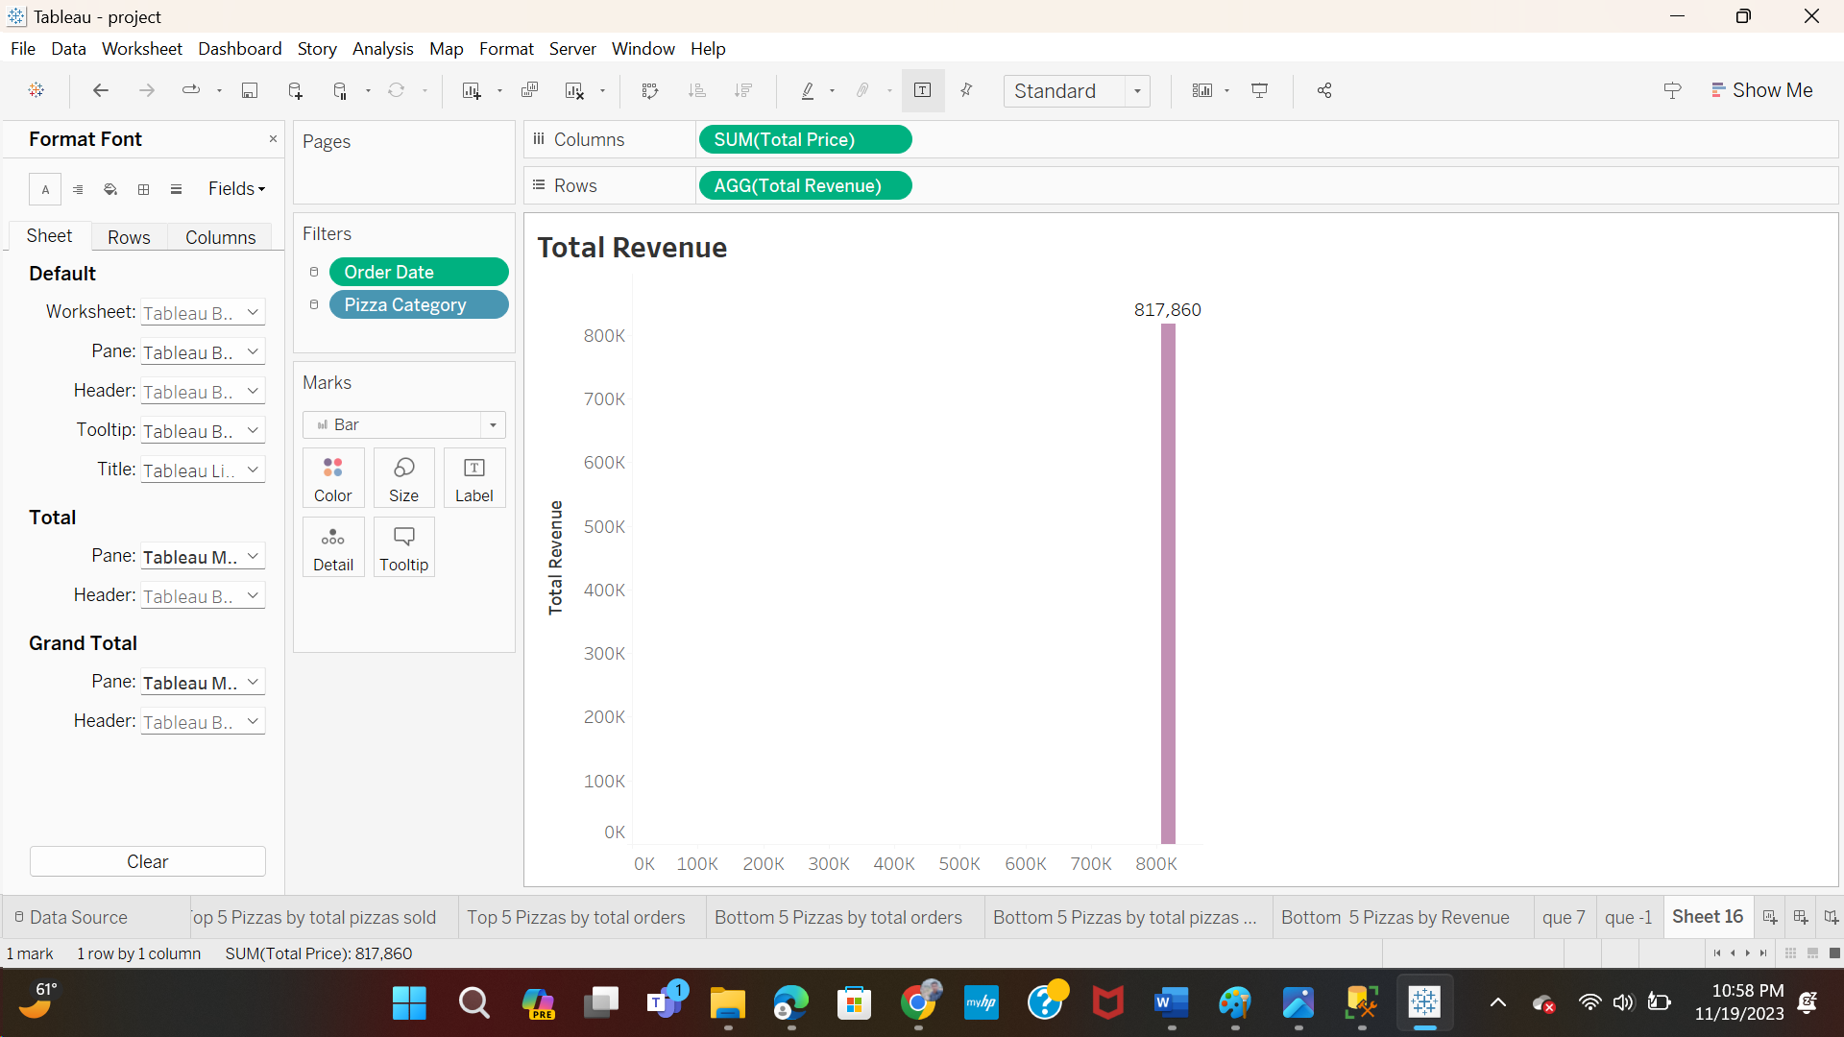

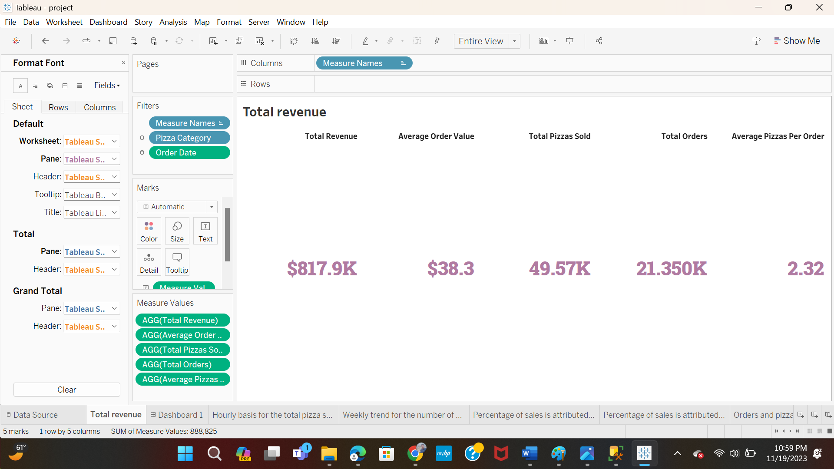

1. **What pizza sales fluctuate on an hourly basis for the total pizza sold?**

Stacked bar chart illustrating hourly pizza sales fluctuations. Sales peak at 12 p.m. (6,776 pizzas), lowest at 9 a.m. (slightly over 4 pizzas). Valuable for resource allocation decisions (employees, inventory, marketing). X-axis: order time, Y-axis: total pizzas sold. Pre-attentive attributes: Size - largest bars for highest sales; Color - purple for peak sales, a bright and contrasting choice.

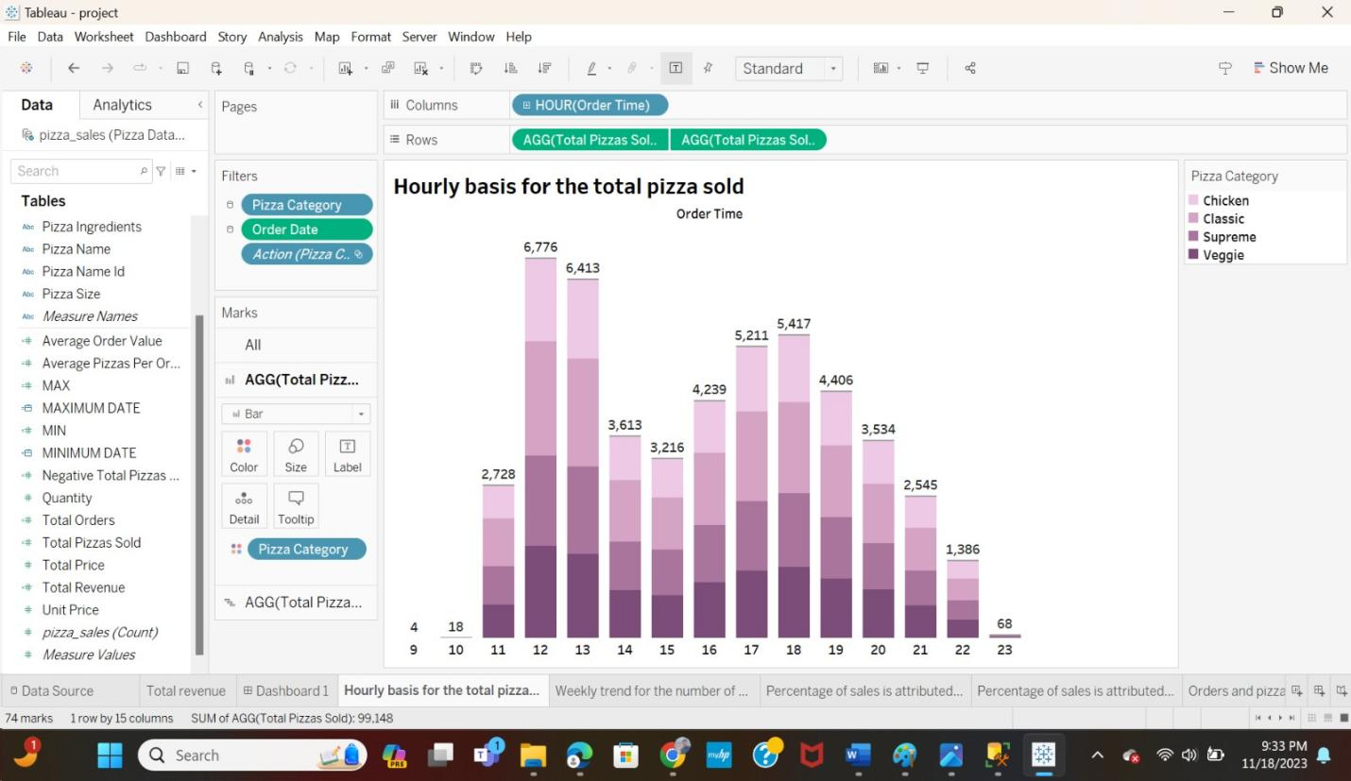

1. **Which pizzas rank highest in terms of total orders, listing the top five?**

Horizontal bar graph displaying pizza popularity. Top three: Classic Deluxe, Hawaiian, Pepperoni. Also popular: Barbecue Chicken, and Thai Chicken. X-axis: total orders, Y-axis: pizza name. Taller bars denote higher popularity; e.g., Classic Deluxe with 2,329 orders. Bars are distinguished by shades of gray.

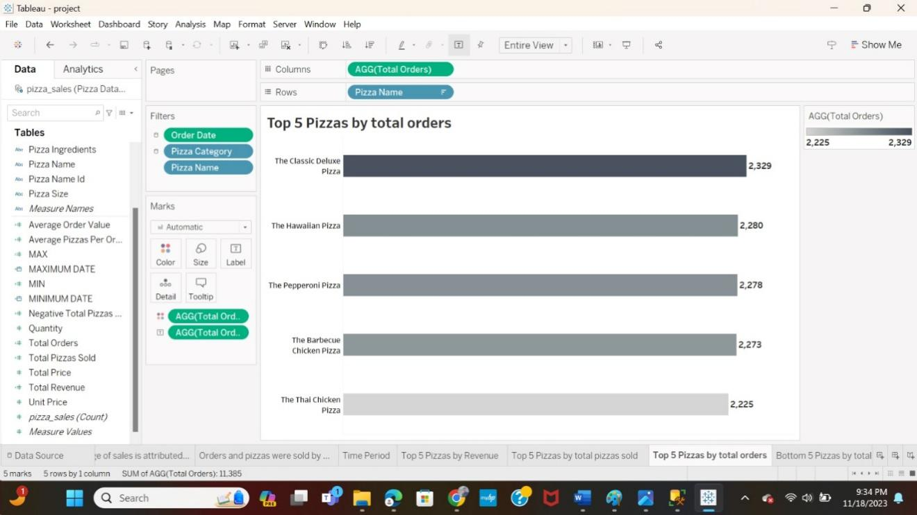

1. **What percentage of sales is attributed to pizza size?**

Bar graph plot

The graph illustrates how the size of the pizza affects the percentage of sales that can be ascribed to it. The largest proportion of sales is made up of giant pizzas, which are followed in popularity by medium, small, and extra-large pizzas. Sales of pizzas are broken down as follows: 45.89% of sales are from big pizzas, 30.49% from medium pizzas, 21.77% from small pizzas, and 1.72% from extra-large pizzas.

The relative popularity of various pizza sizes is displayed in this chart, which makes it significant. Decisions on price, staffing, and inventory levels may be made using this information.

The measure values and total revenue are shown on the x-axis, and the pizza size more specifically, the total revenue as a percentage of sales is shown on the y-axis. The height of each bar represents the percentage of sales for that size.

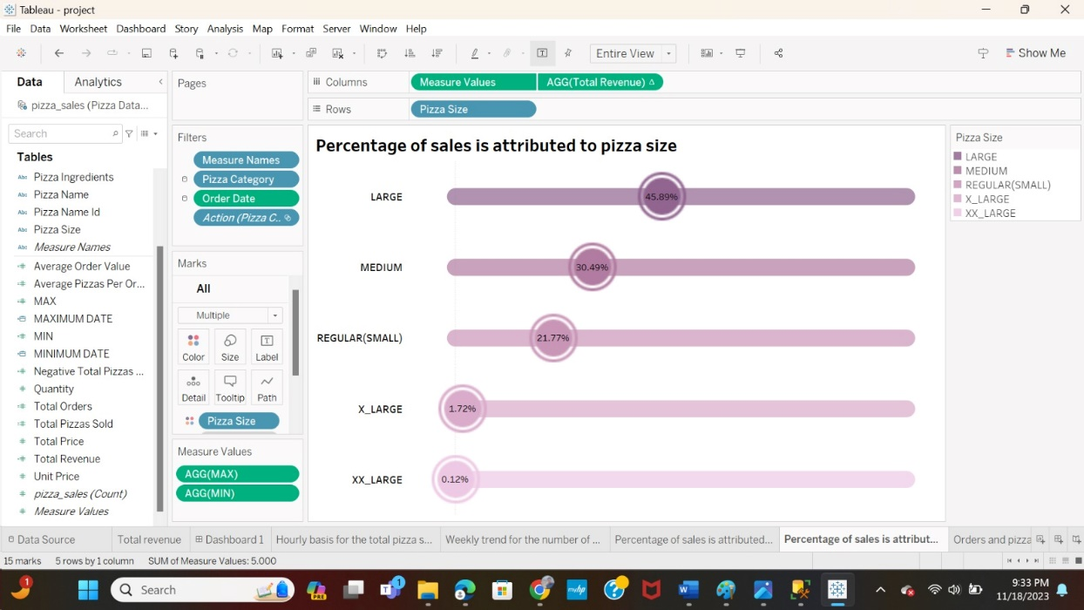

1. **What are the top 5 pizzas by revenue?**

Plot: Horizontal Bar Graph

The top 5 pizzas by revenue are displayed in the chart. The entire income is shown on the x-axis, while the number of pizza names is shown on the y-axis. The pie chart indicates that "The That Chicken" is the best-selling variety, bringing in $43,434K. With $42,768K in sales, the "The Barbecue" pizza is the second best-selling pizza. With $41,410K in sales, the "The California" pizza is the third best-selling pizza. With $38,181K in sales, the "The Classic Deluxe" pizza is the fourth best-selling pizza. With $34,831K in sales, the "The Spicy Italian" pizza is the sixth best-selling variety.

The pre-attentive attributes and colors used in the chart are:

• Length: The length of the bars represents the revenue of each pizza.

• Color: The color of the bars represents the ranking of each pizza by revenue, with the darkest purple bar representing the highest revenue and the lightest purple bar representing the lowest revenue.

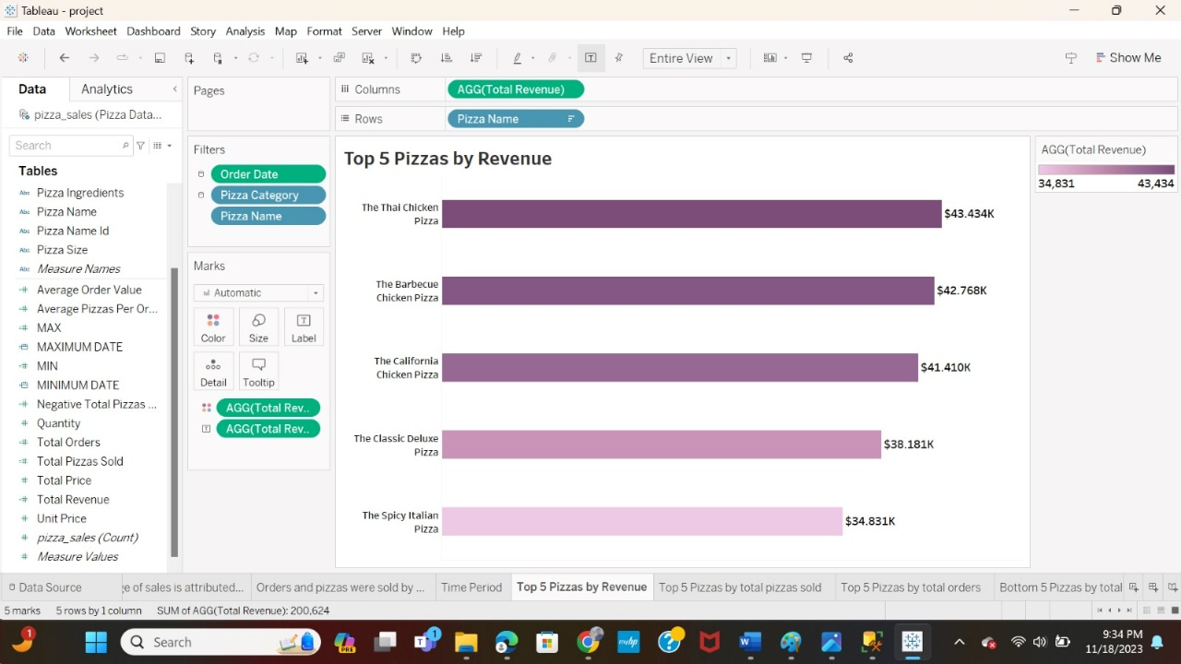

1. **What are the bottom 5 pizzas by revenue?**

Plot: Horizontal Bar Graph

The bottom 5 pizzas by revenue are displayed in the chart. The pizza name is represented by the y-axis, while the total income is shown by the x-axis. With the lightest purple signifying the lowest revenue and the darkest purple representing the most revenue, the bars are colored in a gradient from dark purple to light purple.

The pre-attentive attributes and colors used in the chart are:

• Size: The size of the bars represents the revenue of each pizza.

• Orientation

• Color: The color of the bars represents the ranking of each pizza by revenue, with the lightest purple bar representing the lowest revenue and the darkest purple bar representing the highest revenue.

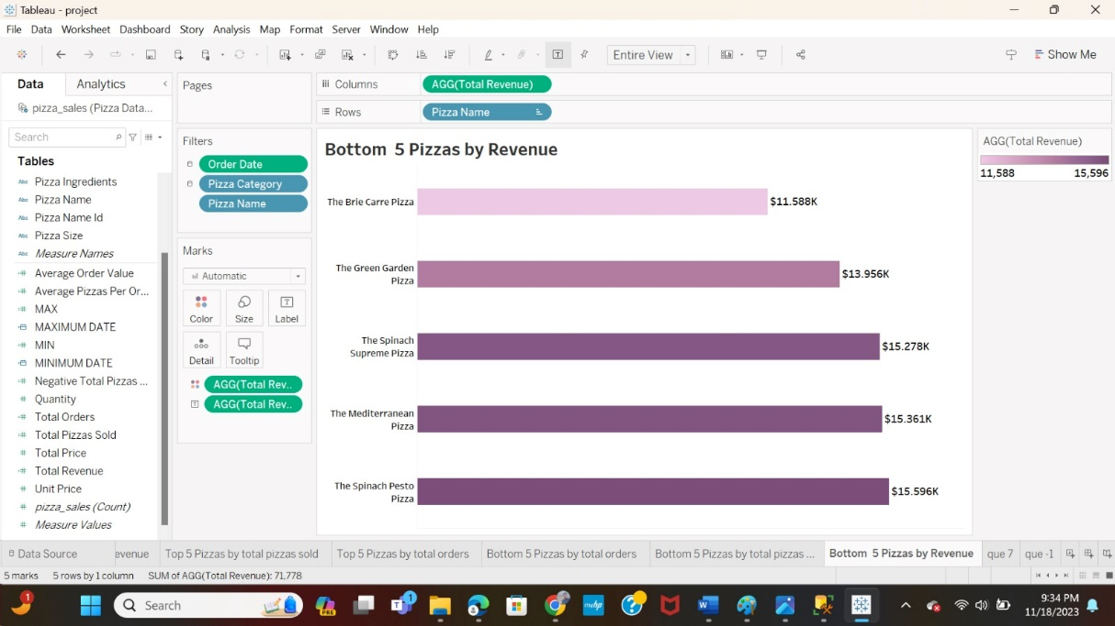

1. **How are pizza sales influenced by both pizza category and time variations?**

Plot: Area Chart

The timing of pizza orders broken down by pizza type is shown in the line or area chart. The order time is plotted on the x-axis, while pizza sales are plotted along the y-axis for each type of pizza. The line chart's vertical segments represent the quantity of pizzas sold during the relevant time periods.

The pre-attentive attributes and colors used in the chart are:

• Position and orientation

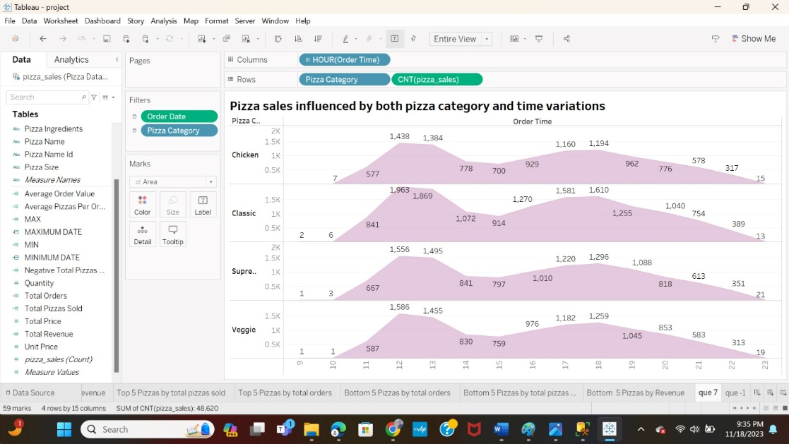

1. **What are the top 5 pizzas by total pizzas sold?**

Plot: Horizontal Bar Graph

Pizza sales totals for the top 5 pizzas are displayed in the chart. Pizza sales as a whole are shown on the x-axis. The entire pizza name is displayed on the y-axis. The bars are tinted in a gradation from light blue to blue, where the lightest blue indicates the least amount of pizzas sold and the darkest blue indicates the most pizzas sold.

The pre-attentive characteristics and colors utilized in the chart are as follows:

• Length: The size of the bars indicates the quantity of pizzas sold; the largest bar denotes the quantity sold greatest, and the smallest bar denotes the quantity sold lowest.

• Color: The bars' color indicates how each pizza is ranked according to how many are sold, with the deepest blue bar representing this information.

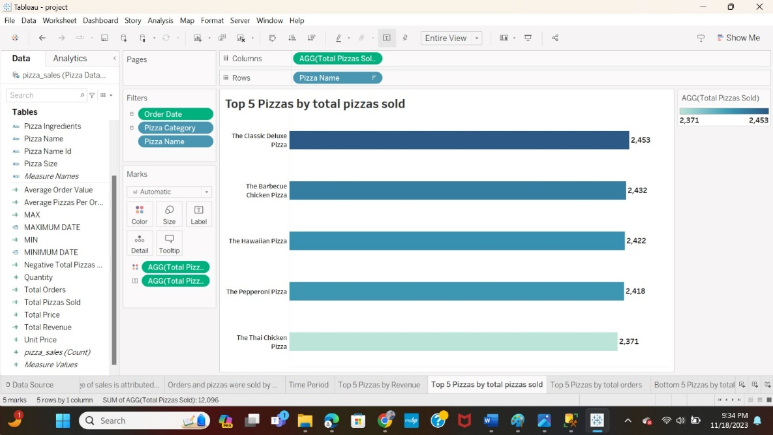

1. **What are the bottom 5 pizzas by total pizzas sold?**

Plot: Horizontal Bar Graph

The ranking displays the lowest five-selling pizzas overall. The name of the pizza is shown on the y-axis, while the total number of pizzas sold is shown on the x-axis.

The chart's pre-attentive characteristics and color schemes are as follows:

• Length

• Color: dark blue, light gray

• Orientation

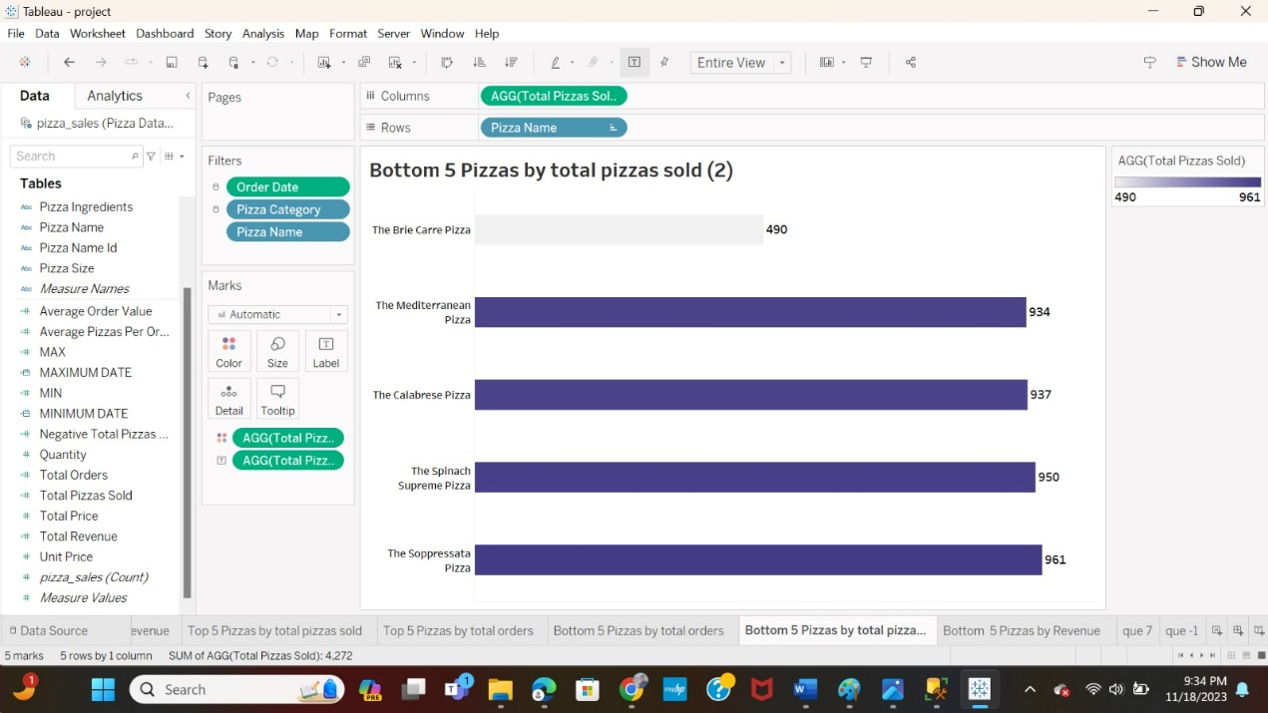

1. **What is the weekly trend for the number of orders?**

Plot: Line Chart

The quantity of orders every week is tracked by the line chart. The order date is shown on the x-axis, while the total orders are shown on the y-axis.

The chart's pre-attentive characteristics and color schemes are as follows:

• Position

• Color: The line representing the trend is colored dark Gray, which is a visually salient colour.

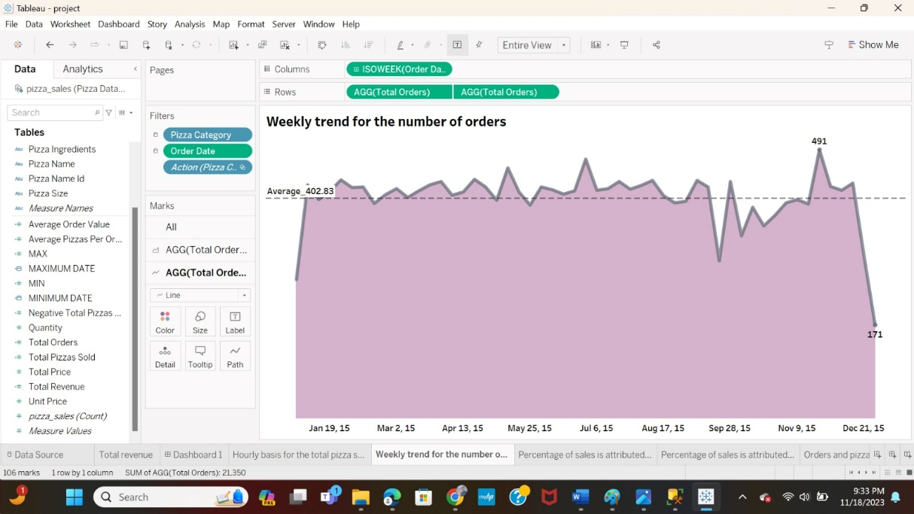

1. **What percentage of sales is attributed to each pizza category?**

Plot: Donut chart

The percentage of sales allocated to each pizza category is displayed on the doughnut chart. Four slices make up the chart, which stands for the four types of pizza: chicken, veggie, classic, and supreme.

• Slice: Category for pizza

• Slice size: Sales as a percentage

The chart's pre-attentive characteristics and color schemes are as follows:

• Color: The intensity of purple color corresponds to each kind of pizza: These hues stand out in the picture and are simple to differentiate from one another.

• Size: Each slice's dimensions correspond to the percentage of sales that it represents. This facilitates the process of determining the most popular pizza categories.

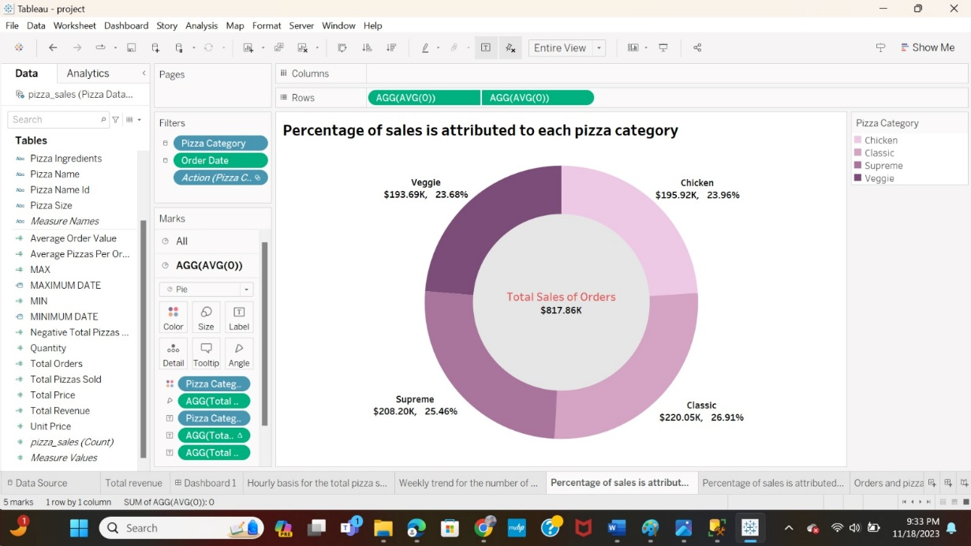

1. **How many orders and pizzas were sold by each pizza category?**

Plot: Stacked bar chart

The picture displays a stacked bar chart with the number of orders and pizzas sold for every kind of pizza. The measure values are shown on the x-axis, while the pizza category is shown on the y-axis. The number of orders is at the bottom of the stacked bars, while the number of pizzas sold is at the top.

Which axis represents which and what:

• X-axis: measure values (stacked)

• Y-axis: pizza category

The pre-attentive attributes and colours used in the chart are:

• Color: Total pizzas orders and Total pizzas sold are represented by purple variation.

• Size: The length of each bar represents the total number of orders and pizzas sold for that pizza category. The width of each bar is the same, so the length of the bar is the only pre-attentive attribute that varies.

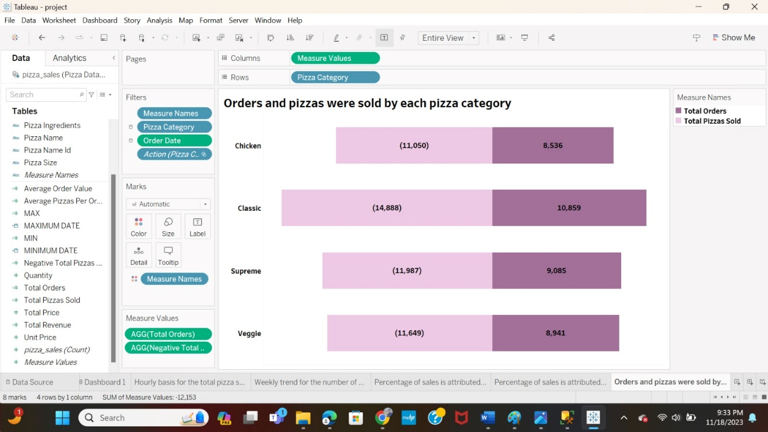

**Section 6: Interactivity**

**6.1 Interactive Visualization Features**

We created the Tableau dashboard using components such as calculated fields, dynamic parameters, and filters. With the help of these tools, users may thoroughly and practically investigate and evaluate pizza sales data in a variety of circumstances.

In this project, a number of computed variables and filters are being utilized, including Average Order Value, Average Pizza Sold, Negative Total Pizza Sold, Maximum Revenue, Minimum Date, and Maximum Date. And filters are the best—chicken, veggie, and classic.

These computed fields enhance the dashboard's analytical capabilities by providing users with helpful metrics and insights for a comprehensive understanding of the pizza sales data. Here are some calculations that have been submitted:

The percentage of sales is calculated using the calculation fields for the lowest and maximum values each pizza size.

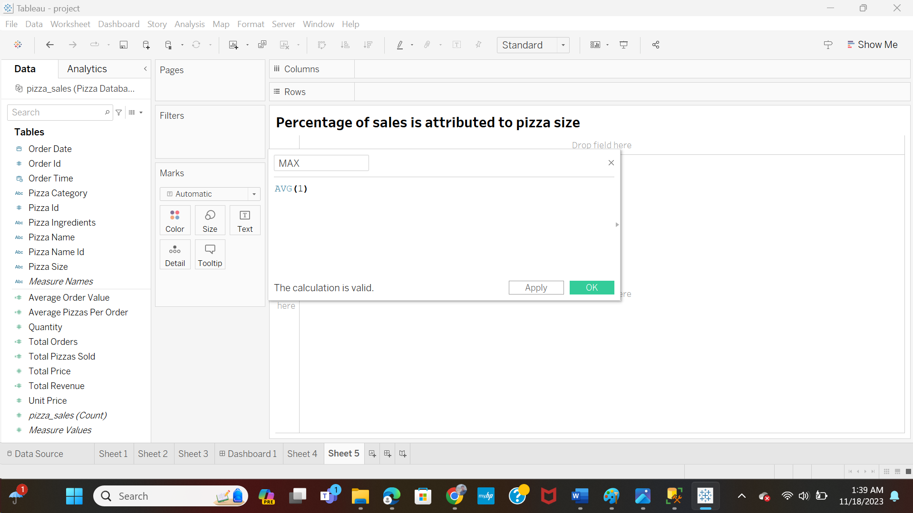

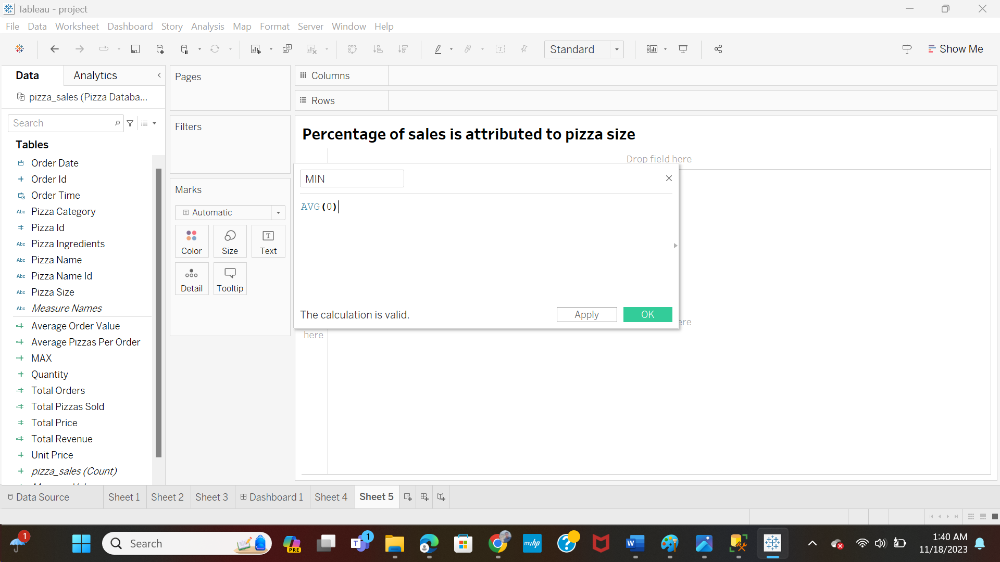

The number of orders and pizzas sold for each pizza category is examined using the calculation variables for the negative average total pizza sales.

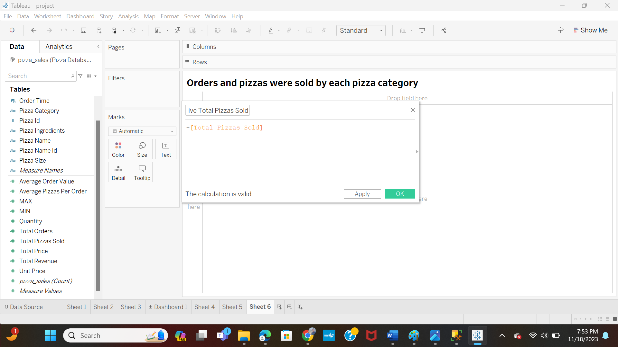

The total dashboard maximum and minimum dates from the year 2015 for the pizza sale dashboard are chosen using the calculation fields for the maximum date and minimum date.

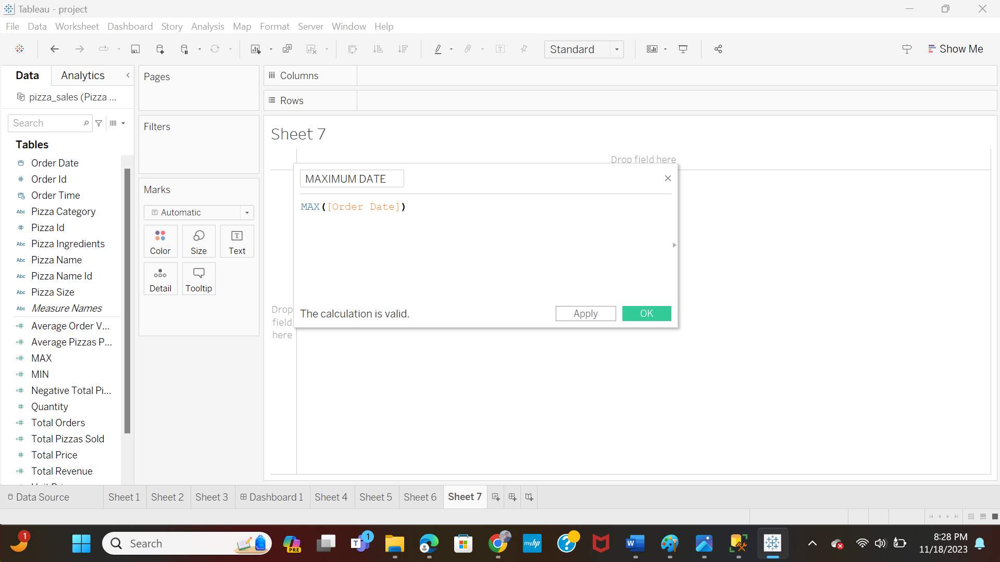

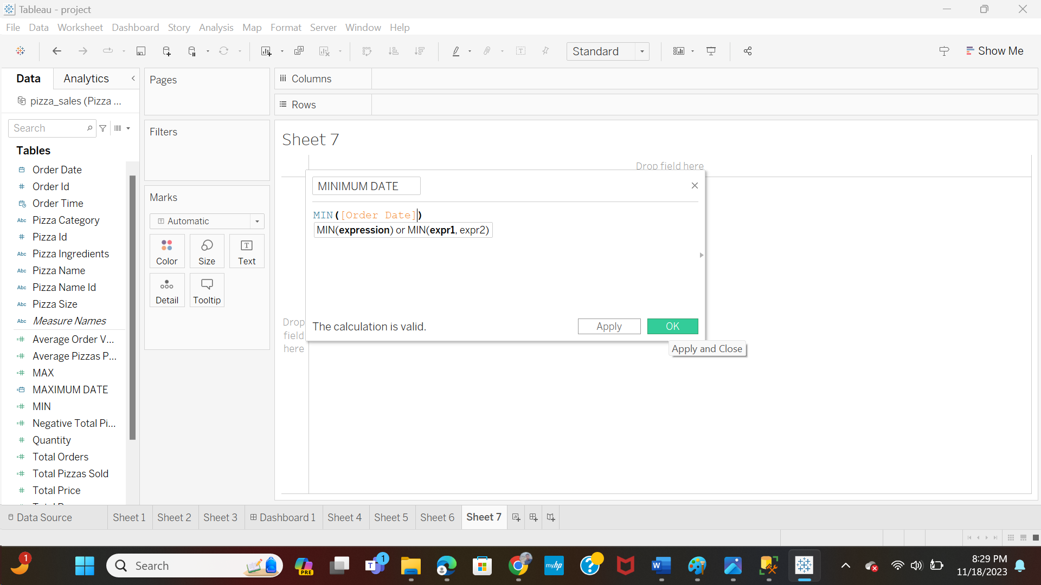

**6.2 Criteria for Examining Pizza Sales Filters and Types:**

* The dashboard for this project is controlled by filters, specifically related to pizza categories such as Chicken Classic, Supreme, and Veggie. These filters influence the presentation and analysis of data within the dashboard.

This dashboard is designed to be influenced by the selection of the chicken pizza category.

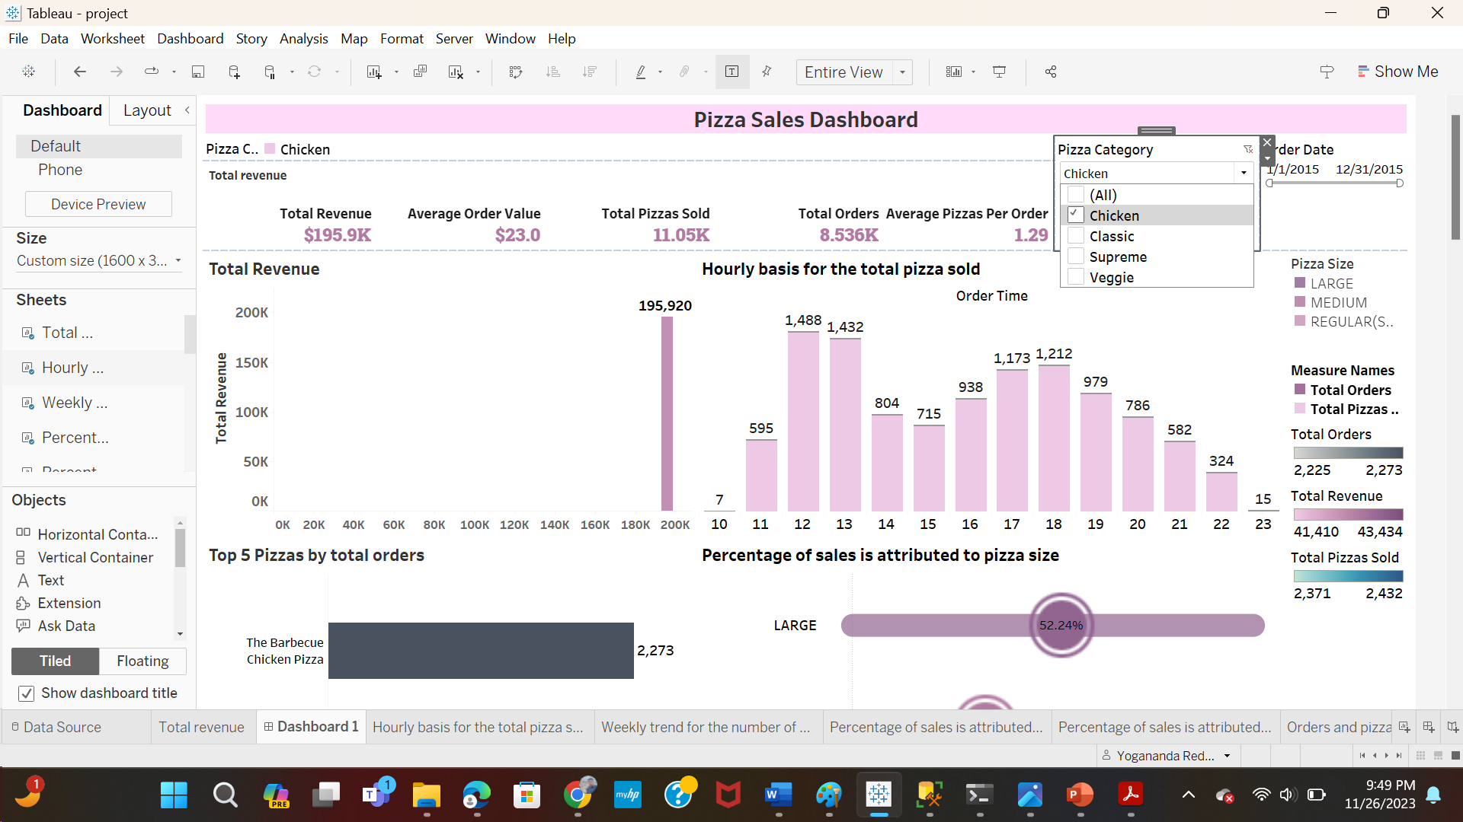

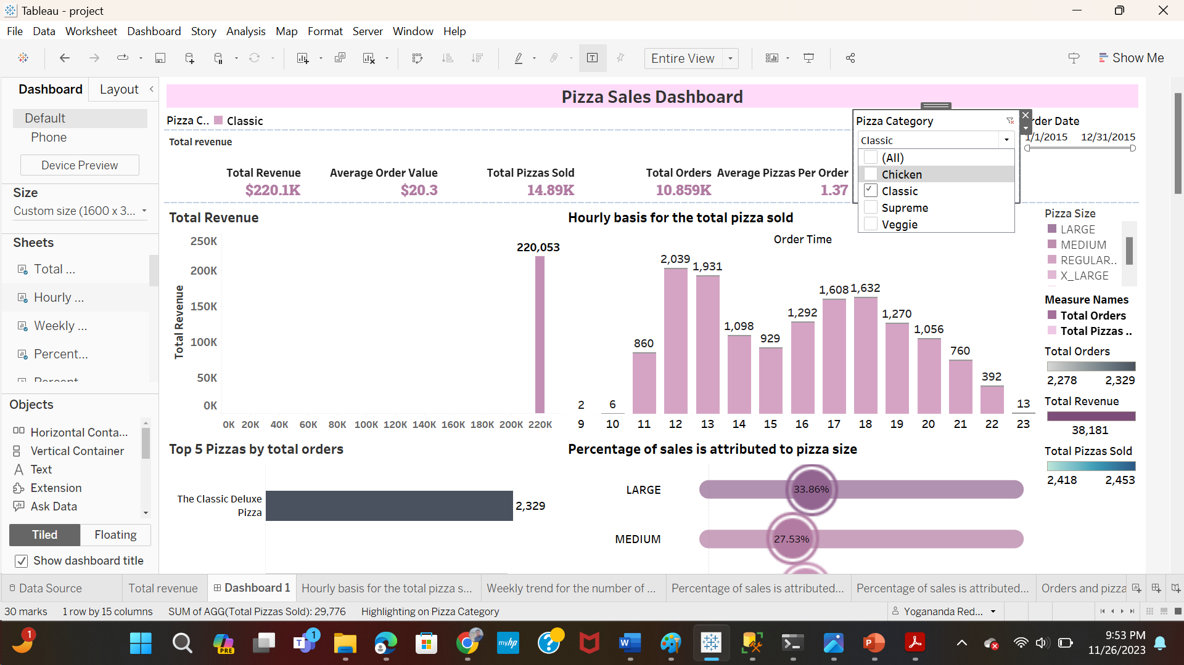

The above dashboard is designed to be influenced by the selection of the classic pizza category.

The below dashboard is designed to be influenced by the selection of the supreme pizza category.

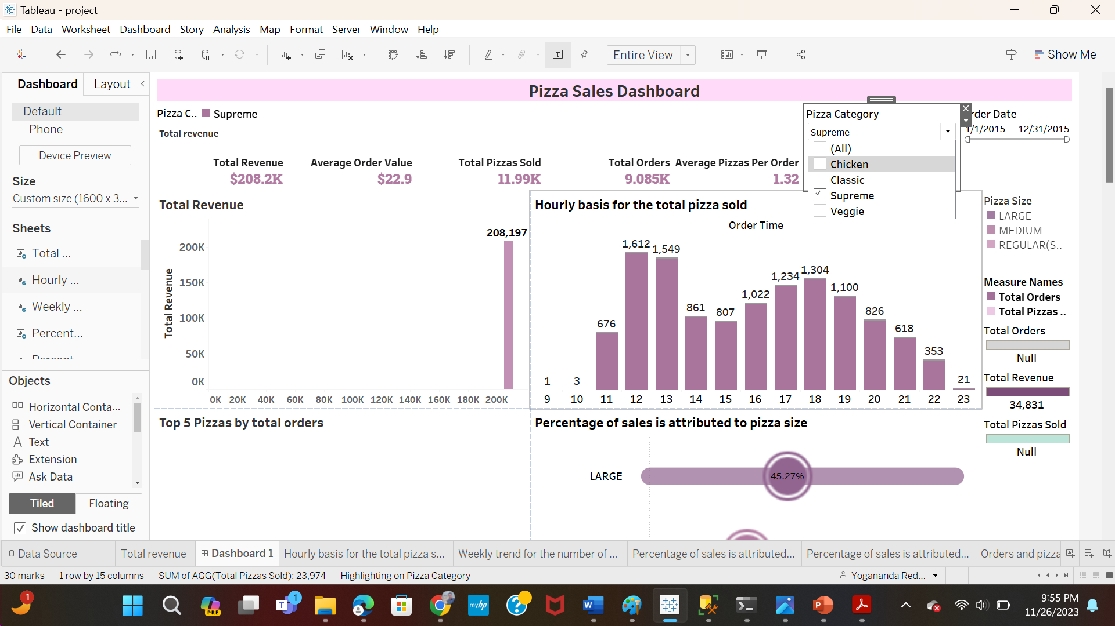

* This project's filters, which include large, small, medium, X-large, and XX-large pizza sizes, are based on pizza sizes.

**6.3 Enhanced Data Analysis through Tableau**

Analyzing Sales Trends: We have effectively used Tableau's data grouping and analysis features. shown the patterns in pizza sales over time. We can learn more about customer preferences and the impact of seasonal factors on sales by examining the volume of pizza sold over time.

Comprehensive Analysis Using Variable Ranges Our system's interactive features, which take a variety of values, enable the investigation of sales data. For instance, our filters allow you to examine sales data over various time periods and categories by adjusting them step-by-step.

**Extra credit:**

The focus of our study is the analysis of a dataset including data on pizza sales. Pizza size, category, ingredients, name, number, order date, time, unit pricing, and total price are among the details included in the collection. This dataset provides possibilities for both visualization and exploration.

We are eager to explore techniques that haven't been discussed in class for our credit work, as per our team's recommendations. These are the ones that we have chosen to investigate.

**Building a Story:**

Tableau enables us to create "stories," which are collections of visuals that highlight different facets of our data. We might write a narrative that walks viewers through the key findings from our data on pizza sales, such as the kind of pizzas sold, when sales are at their highest, or the relationships between popularity and pizza. In the below link, we are created a story.

<https://public.tableau.com/app/profile/yogananda.reddy.murikinati5016/viz/PizzaSalesDashboardProject_17010622549860/Story1?publish=yes>

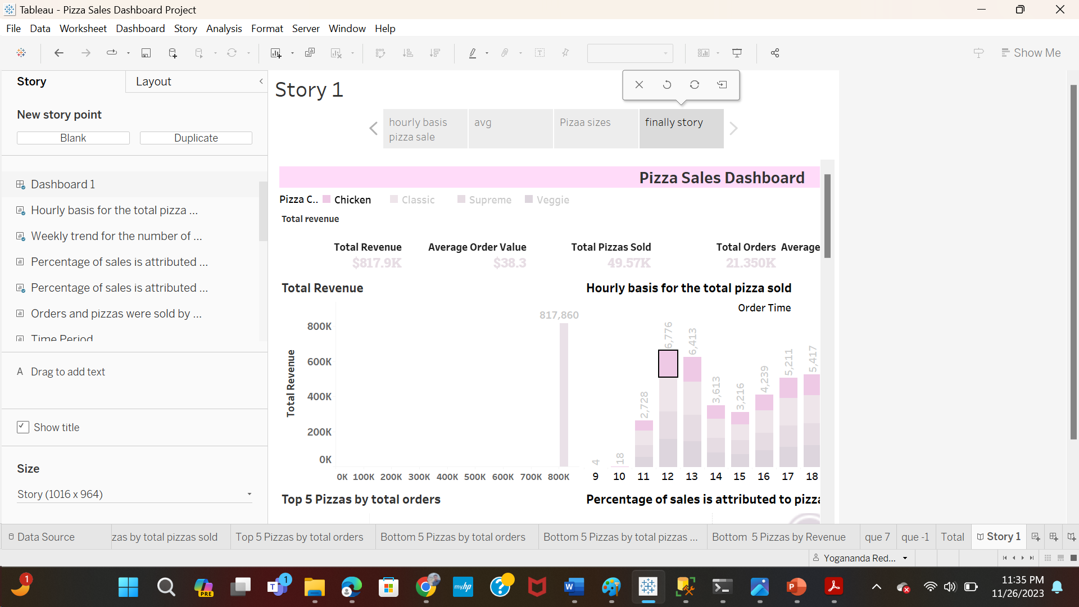

The visualizations below showcase peaks in the data, providing insightful plots.

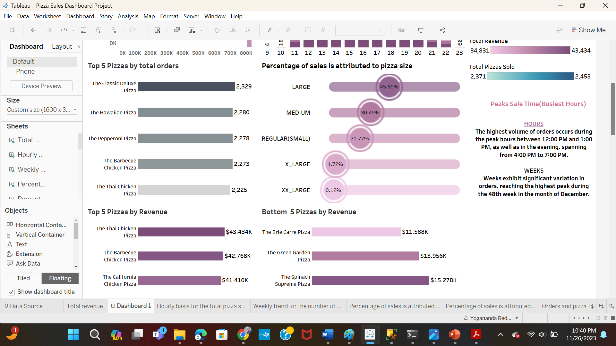

**Dashboard Link:**

<https://public.tableau.com/app/profile/yogananda.reddy.murikinati5016/viz/PizzaSalesDashboardProject_17010622549860/Dashboard1?publish=yes>

**References**

**Dataset link:**

*🍕🍽️ Pizza Restaurant Sales*. (2022, October 21). Kaggle. <https://www.kaggle.com/datasets/shilongzhuang/pizza-sales>

**Mural link:**

<https://app.mural.co/invitation/mural/phase14757/1699563089525?sender=u1a6332ed6ddde045bbc37154&key=c1965fb8-d49b-4a7f-9e4a-0adbe368ba37>

**Class Textbook:**

1. Class Notes, Arizona State University, IFT 598 – 90261 Data Visualization, Reporting in IT.
2. The Big Book of Dashboards, by Steve Wexler Jeffrey Shafer Andy Cotgreave, Wiley 2017